1. Draw a DFA to accept strings of a’s and b’s having exactly one a
2. Obtain a DFA to accept strings of a’s and b’s starting with the string ab
3. Obtain a DFA to accept strings of a’s and b’s ending with the string ab
4. Obtain a DFA to accept strings of a’s and b’s which do not end with the string ab. Show a sequence of moves made by the DFA for the strings “abaaba” and “abab”
5. Obtain a DFA to accept strings of a’s and b’s having a sub string ab
6. Obtain a DFA to accept strings of a’s and b’s having a sub string aab
7. Obtain a DFA to accept strings of a’s and b’s ending with ab or ba
8. Draw a DFA to accept string of 0’s and 1’s having no 3 consecutive 0’s
9. Draw a DFA to accept string of a’s and b’s having at least four a’s
10. Draw a DFA to accept strings of a’s and b’s having not more than 3 a’s
11. Draw a DFA to accept string of a’s and b’s having exactly three a’s
12. Draw a DFA to accept string of a’s and b’s such that no two consecutive characters are same.
13. Draw a DFA to accept an integer with optional sign
14. Draw a DFA to accept a floating point number with optional sign
15. Obtain a dfa to accept strings of 0’s 1’s and ‘s beginning with ‘0’ followed by odd number of 1’s and ending with 2’s
16. Obtain a DFA to accept strings of a’s and b’s with at most 2 consecutive b’s
17. Obtain a DFA to accept strings of 0’s and 1’s starting with atleast two 0’s and ending with atleast two 1’s
18. Obtain a dfa to accept the language ending with L={wbab | wЄ {a,b}*}
19. Draw a dfa to accept set of all strings on the alphabet ∑ = {0,1} that either begins or ends or both with the substring 01
20. Draw a DFA to accept the language L={ w: $n_{a}\left(w\right)≥1,$ $n_{b}\left(w\right)=$ 2}
21. Draw a DFA to accept the language L={ w: $n_{a}\left(w\right)=2,$ $n_{b}\left(w\right)≥$ 3}
22. Draw a DFA to accept decimal strings divisible by 3.
23. Obtain the dfa to accept strings of even number of a’s
24. Obtain a dfa to accept L={wЄ {a,b}: every ‘a’ region in w is of even length
25. Obtain a dfa to accept strings of a’s and b’s having even number of symbols
26. Obtain a dfa to accept L={wЄ {a,b}: where every a is immediately followed by b
27. Obtain a dfa to accept L={wЄ {a,b}: w has odd parity
28. Obtain a dfa to accept L={w:|w|mod 3=0} where Є =a
29. Obtain a dfa to accept L={w:|w|mod 3=0} on ∑ ={a,b}
30. Obtain a dfa to accept L={$n_{a}$ (w)mod 3=0} on ∑ ={a,b}
31. Obtain a dfa to accept L={$n_{a}$ (w)mod 3≠0} on ∑ ={a,b}
32. Obtain a dfa to accept L={$n_{a}$ (w)mod 5≠0} on ∑ ={a}
33. Obtain a dfa to accept strings of a’s and b’s with even number of a’s and b’s
34. Obtain a dfa to accept even number of a’s and odd number of b’s
35. Obtain a dfa to accept odd number of a’s and even number of b’s
36. Obtain a dfa to accept odd number of a’s and odd number of b’s
37. Obtain a dfa to accept odd and even numbers using binary notation
38. Obtain a dfa to accept L={w:|w|mod 5≠0} on ∑ ={a,b}
39. Convert the following NFA to DFA

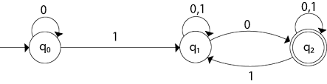

1. Convert the following NFA to DFA

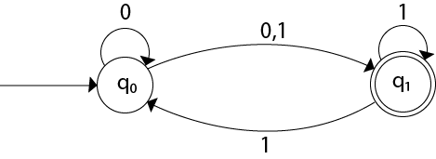

1. Convert the following NFA to DFA using subset construction method

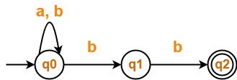

1. Convert the following NFA to DFA

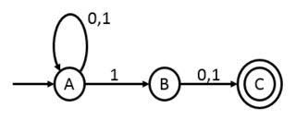

1. Convert the following NFA to DFA using subset construction method

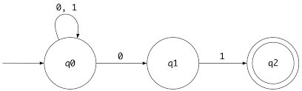

1. Convert the following NFA to DFA

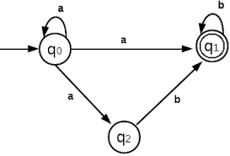

1. Convert the following NFA to DFA using subset construction method

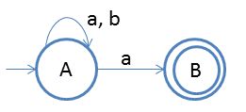

1. Convert the following 𝛆-NFA to DFA

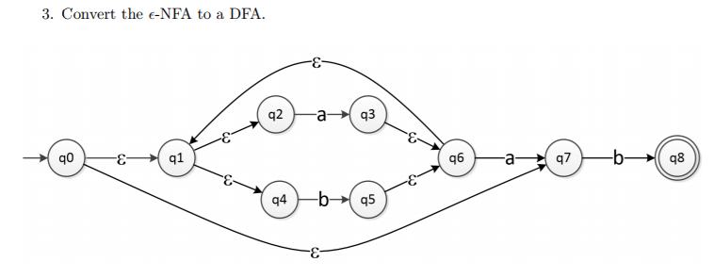

1. Convert the following 𝛆-NFA to DFA

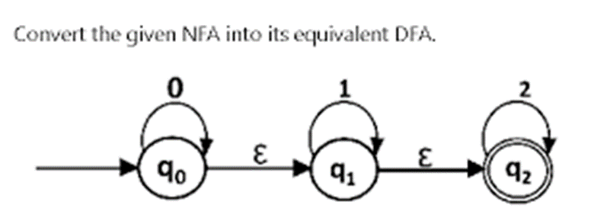

1. Convert the following 𝛆-NFA to DFA

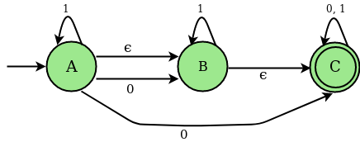

1. Convert the following 𝛆-NFA to DFA

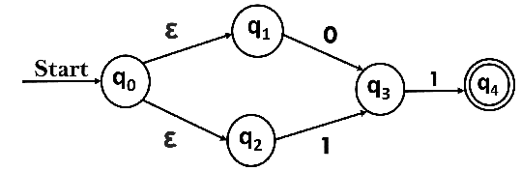

1. Convert the following 𝛆-NFA to DFA

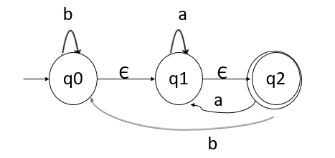

1. Convert the following 𝛆-NFA to DFA

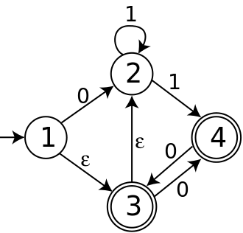

1. Minimize the following DFA

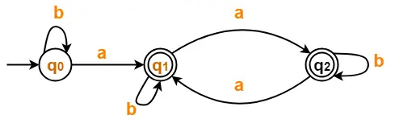

1. Minimize the following DFA

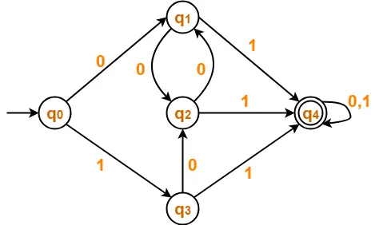

1. Minimize the following DFA

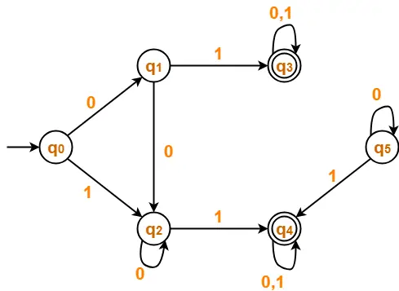

1. Minimize the following DFA

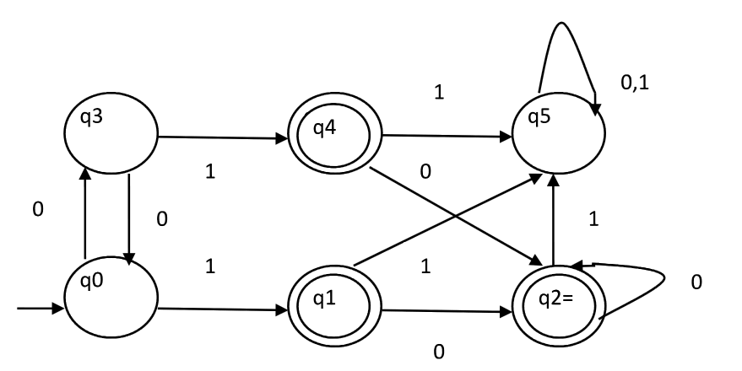

1. Minimize the following DFA

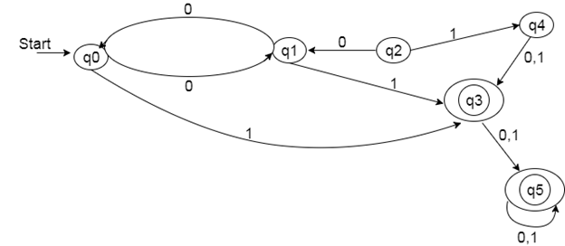

1. Minimize the given transition table

|  |  |  |
| --- | --- | --- |
|  | a | B |
| A | B | F |
| B | G | C |
| C | A | C |
| D | C | G |
| E | H | F |
| F | C | G |
| G | G | E |
| H | G | C |

Write the regular expression for the language accepting all combinations of a's, over the set ∑ = {a}

R = a*

Write the regular expression for the language accepting all combinations of a's except the null string, over the set ∑ = {a}

R = a+

1. a's and b's of length 2

aa + ab + ba + bb OR (a+b)(a+b)

2. a's and b's of length ≤ 2

ε + a + b + aa + ab + ba + bb OR (ε + a + b)(ε + a + b) OR (a+b)? (a+b)?

3. a's and b's of length ≤ 10

(ε + a + b)10

4. Even-lengthed strings of a's and b's

(aa + ab + ba + bb)* OR ((a+b)(a+b))*

5. Odd-lengthed strings of a's and b's

(a+b) ((a+b)(a+b))*

6. L(R) = { w : w ∈ {0,1}* with at least three consecutive 0's }

(0+1)* 000 (0+1)*

7. Strings of 0's and 1's with no two consecutive 0's

(1+ 0 1*)* OR (11* 0 1*)* OR (1 + 01)* (0 + ε)

8. Strings of a's and b's starting with a and ending with b.

a (a+b)* b

9. Strings of a's and b's whose second last symbol is a.

(a+b)* a (a+b)

10. Strings of a's and b's whose third last symbol is a and fourth last symbol is b.

(a+b)* b a (a+b) (a+b)

11. Strings of a's and b's whose first and last symbols are the same.

(a (a+b)* a) + (b (a+b)* a)

12. Strings of a's and b's whose first and last symbols are different.

(a (a+b)* b) + (b (a+b)* a)

13. Strings of a's and b's whose last and second last symbols are same.

(a+b)* (aa + bb)

14. Strings of a's and b's whose length is even or a multiple of 3 or both.

R1 + R2 where R1 = ((a+b)(a+b))*   and   R2 = ((a+b)(a+b)(a+b))*

15. Strings of a's and b's such that every block of 4 consecutive symbols has at least 2 a's.

(aaxx + axax + axxa + xaax + xaxa + xxaa)* where x = (a+b)

16. L = {anbm : n ≥ 0, m ≥ 0}

a* b*

17. L = {anbm : n > 0, m > 0}

aa* bb* OR a+b+

18. L = {anbm : n + m is even}

aa* bb* + a(aa)* b(bb)*

19. L = {a2nb2m : n ≥ 0, m ≥ 0}

(aa)* (bb)*

20. Strings of a's and b's containing not more than three a's.

b* (ε + a) b* (ε + a) b* (ε + a) b*

21. L = {anbm : n ≥ 3, m ≤ 3}

aaa a* (ε + b) (ε + b) (ε + b)

22. L = { w : |w| mod 3 = 0 and w ∈ {a,b}* }

( (a+b)(a+b)(a+b) )*

23. L = { w : na(w) mod 3 = 0 and w ∈ {a,b}* }

b* a b* a b* a b*

24. Strings of 0's and 1's that do not end with 01

(0+1)* (00 + 10 + 11)

25. L = { vuv : u, v ∈ {a,b}* and |v| = 2}

(aa + ab+ ba + bb) (a+b)* (aa + ab + ba + bb)

26. Strings of a's and b's that end with ab or ba.

(a+b)* (ab + ba)

27. L = {anbm : m,n ≥ 1 and mn ≥ 3}

This can be broken down into 3 problems:

1. n = 1, m ≥ 3
2. n ≥ 3, m = 1
3. n ≥ 2, m ≥ 2

a bbb b* + aaa a* b + aa a* bb b*

28. Write the regular expression for the language accepting all the string containing any number of a's and b's.

r.e. = (a + b)*

29. Write the regular expression for the language accepting all the string which are starting with 1 and ending with 0, over ∑ = {0, 1}.

R = 1 (0+1)* 0

30. Write the regular expression for the language starting and ending with a and having any having any combination of b's in between.

R = a b* b

31. Write the regular expression for the language starting with a but not having consecutive b's.

R = {a + ab}*

32. Write the regular expression for the language accepting all the string in which any number of a's is followed by any number of b's is followed by any number of c's.

R = a* b* c*

33. Write the regular expression for the language over ∑ = {0} having even length of the string.

R = (00)*

34. Write the regular expression for the language having a string which should have atleast one 0 and alteast one 1.

R = [(0 + 1)* 0 (0 + 1)* 1 (0 + 1)*] + [(0 + 1)* 1 (0 + 1)* 0 (0 + 1)*]

35. Describe the language denoted by following regular expression

r.e. = (b* (aaa)* b*)*

36. Describe the language denoted by following regular expression

r.e. = (b* (aaa)* b*)*

The language can be predicted from the regular expression by finding the meaning of it. We will first split the regular expression as:

r.e. = (any combination of b's) (aaa)* (any combination of b's)

L = {The language consists of the string in which a's appear triples, there is no restriction on the number of b's}

37. Write the regular expression for the language L over ∑ = {0, 1} such that all the string do not contain the substring 01.

R = (1* 0*)

1. Write the regular expression for the language containing the string over {0, 1} in which there are at least two occurrences of 1's between any two occurrences of 1's between any two occurrences of 0's.

At least two 1's between two occurrences of 0's can be denoted by (0111*0)*.

Similarly, if there is no occurrence of 0's, then any number of 1's are also allowed. Hence the r.e. for required language is:

1. R = (1 + (0111*0))*
2. Write the regular expression for the language containing the string in which every 0 is immediately followed by 11.

R = (011 + 1)*

1. Write the regular expression for the language containing the string over {0, 1} in which there are at least two occurrences of 1's between any two occurrences of 1's between any two occurrences of 0's.

Solution: At least two 1's between two occurrences of 0's can be denoted by (0111*0)*.

Similarly, if there is no occurrence of 0's, then any number of 1's are also allowed. Hence the r.e. for required language is

R = (1 + (0111*0))*

1. Write the regular expression for the language containing the string in which every 0 is immediately followed by 11.

R = (011 + 1)*

1. Find a regular expression corresponding to the language of all strings over the alphabet { a, b } that do not end with ab.  
     
   Solution: Any string in a language over { a , b } must end in a or b. Hence if a string does not end with ab then it ends with a or if it ends with b the last b must be preceded by a symbol b. Since it can have any string in front of the last a or bb, ( a + b )*( a + bb ) is a regular expression for the language.
2. Find a regular expression corresponding to the language of all strings over the alphabet { a, b } that contain no more than one occurence of the string aa.  
     
   Solution: If there is one substring aa in a string of the language, then that aa can be followed by any number of b. If an a comes after that aa, then that a must be preceded by b because otherwise there are two occurences of aa. Hence any string that follows aa is represented by ( b + ba )*. On the other hand if an a precedes the aa, then it must be followed by b. Hence a string preceding the aa can be represented by ( b + ab )*. Hence if a string of the language contains aa then it corresponds to the regular expression ( b + ab )*aa( b + ba )* .  
   If there is no aa but at least one a exists in a string of the language, then applying the same argument as for aa to a, ( b + ab )*a( b + ba )* is obtained as a regular expression corresponding to such strings.  
   If there may not be any a in a string of the language, then applying the same argument as for aa to , ( b + ab )*( b + ba )* is obtained as a regular expression corresponding to such strings.  
   Altogether ( b + ab )*(  + a + aa )( b + ba )* is a regular expression for the language.

44. Find a regular expression corresponding to the language of strings of even lengths over the alphabet of { a, b }.  
  
Solution: Since any string of even length can be expressed as the concatenation of strings of length 2 and since the strings of length 2 are aa, ab, ba, bb, a regular expression corresponding to the language is ( aa + ab + ba + bb )*. Note that 0 is an even number. Hence the string  is in this language.  
  
45. Describe as simply as possible in English the language corresponding to the regular expression a*b(a*ba*b)*a* .  
  
Solution: A string in the language can start and end with a or b, it has at least one b, and after the first b all the b's in the string appear in pairs. Any numbe of a's can appear any place in the string. Thus simply put, it is the set of strings over the alphabet { a, b } that contain an odd number of b's  
  
  
46. Describe as simply as possible in English the language corresponding to the regular expression (( a + b )3)*(  + a + b ) .  
  
Solution: (( a + b )3) represents the strings of length 3. Hence (( a + b )3)* represents the strings of length a multiple of 3. Since (( a + b )3)*( a + b ) represents the strings of length 3n + 1, where n is a natural number, the given regular expression represents the strings of length 3n and 3n + 1, where n is a natural number.  
47.  Describe as simply as possible in English the language corresponding to the regular expression ( b + ab )*( a + ab )*.  
  
Solution: ( b + ab )* represents strings which do not contain any substring aa and which end in b, and ( a + ab )* represents strings which do not contain any substring bb. Hence altogether it represents any string consisting of a substring with no aa followed by one b foll owed by a substring with no bb.

1. RE using kleen’s theorem

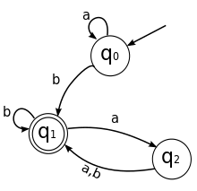

1. 2. RE using Kleen’s theorem

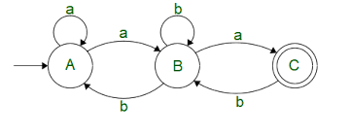

3.

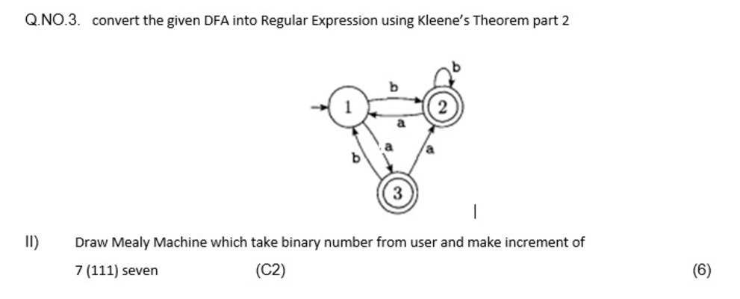

4.

